Complete Architecture
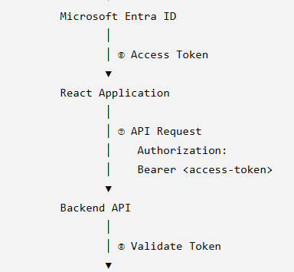
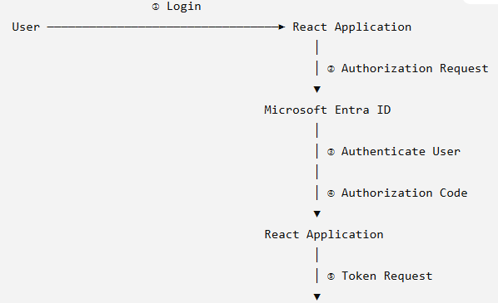

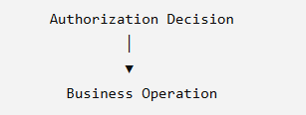

PKCE Proof Key for Code Exchange.
Modern React applications normally use the Authorization Code Flow with PKCE.
PKCE protects the OAuth 2.0 authorization-code flow by requiring the application to prove that it is the same application that initiated the authorization request.
PKCE is not a replacement for JWT, OAuth2, or RBAC.

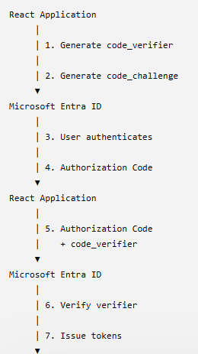
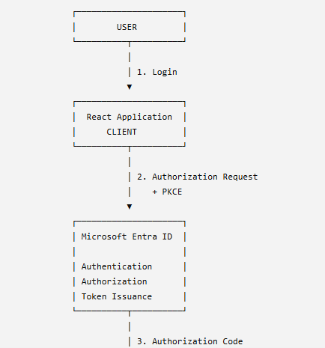

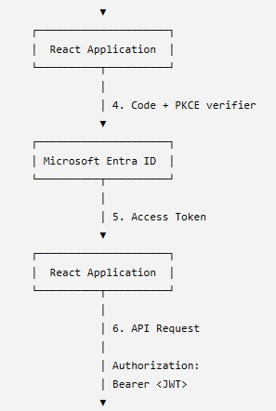
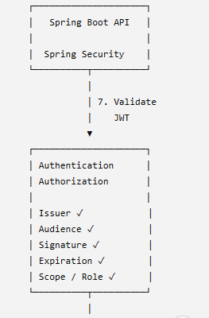

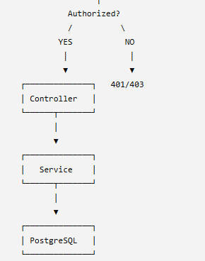

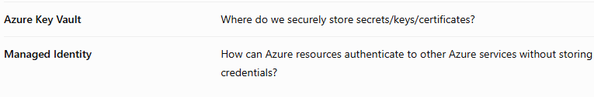
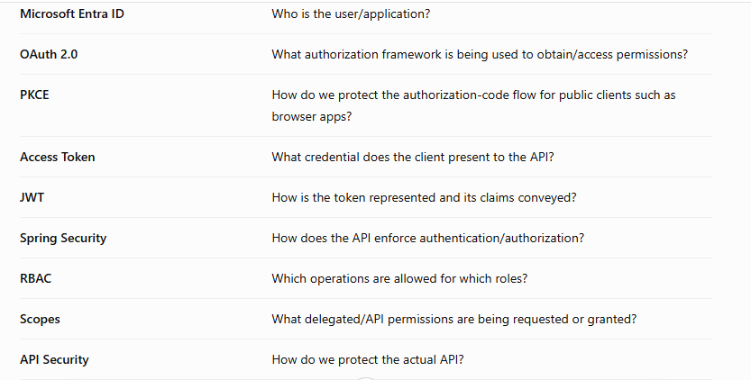

Summary
- Microsoft Entra ID authenticates the user and participates in issuing authorization tokens.
- OAuth 2.0 defines the authorization flow.
- PKCE protects the authorization-code flow for the browser application.
- The React application obtains an access token and sends it to the backend API as a Bearer token.
- The backend validates that the token is genuine, issued by the expected authority, intended for the API, unexpired, and contains the required permissions.
- Only after authentication and authorization succeed does the request reach the banking business logic and database.
OAuth 2.0--- Authorization framework
PKCE --Protects authorization-code exchange
JWT -- Token format
RBAC -- Access control based on roles
Entra ID -- Identity and token provider

The application needs to know:
- Who is this person?
- Did a trusted identity provider authenticate them?
- Is their login still valid?
- What application are they accessing?
- What APIs are they allowed to call?
- What operations are they allowed to perform?
This is where Microsoft Entra ID, OAuth 2.0, access tokens, JWT and API authorization work together.
The different players or actors
1.User
2.React Application -Client
3. Microsoft Entra ID
4. Backend API --customer and account-service
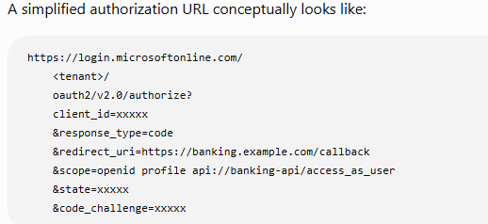

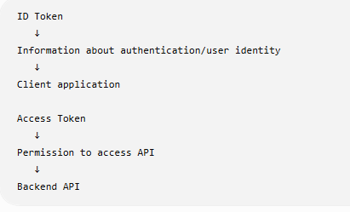
Difference between the ID Token and Acess Token
Application to Backend-API – Bearer Token
Whoever possesses the token can present it as proof of authorization, subject to the API's validation and authorization rules. Therefore it should be protected carefully
Never
